Microinverter
User Manual
V1.0
NBQ400-EU
NBQ500-EU
NBQ600-EU

Statement:
Before using this product, please read this document carefully to ensure that you fully understand this product and can use it correctly. After reading this document, please keep it properly for future reference.
Improper operation of the product may result in serious injury to oneself or others, or damage to the product and other property. When you use the product, you are deemed to have understood, acknowledged and accepted all the terms and conditions of this document. The Company shall not be liable for any loss caused by the user failing to operate the product in accordance with the instructions.
In accordance with laws and regulations, the Company reserves the final interpretation of this document and all documents related to the product. This document is subject to update without notice, please visit the official website for the latest version.

catalogue
1. Important instructions 4
1.1 Product range 4
1.2 symbol description 4
2. safety criterion 5
2.1 Important safety instructions 5
2.2 Environmental requirements 5
3. Delivery list 5
4. summary 6
4.1 Overview of the grid-connected photovoltaic inverter system 6
4.2 Overview of the micro-inverters 7
4.3 compatibility 7
4.4 Visual dimensions (mm) 7
4.5 function Introduction 7
4.6 System monitoring 8
5. install 8
5.1 Installation requirements 8
5.2 Install the required parts and tools 9
5.3 Installation steps 9
6. APP 13
6.1 download APP 13
6.2 Registered account 13
6.3 Connect to the micro-inverter 13
6.4 APP interface 14
7. debugging 16
7.1 LED status indication 16
7.2 Replace the micro-inverter 16
8. data sheet 17
9. appendix 19
9.1 Attachment 1. Installation map 19
9.2 Attachment 2 wiring diagram 20

Important instructions

Product range
This manual describes the assembly, installation, commissioning, maintenance and troubleshooting of the following models of micro-inverters.
NBQ 400-EU
NBQ500-EU
NBQ600-EU
* Note: "400" means 400 W, "500" means 500 W, and "600" means 600 W.

symbol description
notation | instructions
High voltage hazard
High voltages in microinverters can be life-threatening.
caveat
Do not get within 8 inches (20 cm) of the microinverter while it is operating.
Watch out for the heat.
The inverter heats up during operation and should be operated to avoid contact with metal surfaces.
Disposal of equipment
Electronic equipment should not be disposed of with household waste, and old, unusable appliances must be collected and disposed of separately, in accordance with local ordinances or regulations.
CE mark
The microinverters are labeled with the CE mark to certify that the device complies with the European Low Voltage and EMC Directives.
Operating Instructions
Please read the instruction manual carefully before using this product.
 | earth (wire)  The AC cable contains a ground wire and can therefore be grounded directly. For areas with special requirements, a grounding bracket is installed to complete the external grounding.
 | RoHs symbol  The product complies with 2011/65/EU & (EU) 2015/863.

safety criterion

Important safety instructions
- Before installing, using, or repairing this product, please carefully read all the documents, which may be changed due to the product updates or other reasons.
- All operations, including transport, installation, start-up and maintenance, must be performed by trained and qualified personnel.
- Before installation, check the packaging and appearance of the equipment to ensure that there is no damage during transportation.
- Before connecting, ensure that all cables and plugs are intact and dry to avoid electric shock.
- Before the installation, ensure that the solar photovoltaic panels and the micro inverters are not connected to the home power supply.
- Personal protective equipment such as gloves and goggles must be used during installation.
- Do not install or operate equipment in extreme weather conditions, such as lightning, snow, heavy rain, strong winds, etc.
- Warning signs on the equipment shall not be damaged, smeared or torn off.
- After installation, remove the installed legacy, such as cut cable tie, torn insulation materials, etc.
- Do not try to repair the micro inverter, please contact our customer support and start the replacement procedure. Private maintenance or opening of the micro-inverter will lead to the failure of the warranty policy.
- Understand the components and functions of the grid-connected PV system and ensure that all electrical connections as well as the voltage and frequency of the equipment meet local electrical standards.
- Be extremely careful whenever the inverter is disconnected from the public power grid, as some components may retain sufficient charge, causing a risk of electric shock.
- Ensure that the micro-inverters are firmly installed to prevent falling accidents or damage to the product.
- For safety reasons, the equipment shall use original or authorized cables and we are not responsible for damage to the equipment caused by the use of third party accessories.

Environmental requirements
- Ensure that the equipment is installed, operated or stored in a well ventilated place. insufficient ventilation can cause permanent damage to the equipment.
- Do not install or place this equipment in a strong current and strong magnetic field environment to avoid radio interference.
- Do not install the equipment in a flammable, explosive, corrosive, extremely hot, extremely cold, and humid environment.
- Do not install the device where children and pets can touch it.

Delivery list
- Micro-inverter * 1
- Power cord * 1
- User Manual * 1
- M8 screw combination * 2
pour:
  - If any accessories are missing, please contact the customer service department.
  - Other tools and accessories involved in the installation and debugging are not included in the package list. If you need to use them, please purchase them separately.

summary

Overview of the grid-connected photovoltaic inverter system
The grid-connected photovoltaic inverter system includes photovoltaic modules, micro inverters, meters and power grid. The micro inverter converts the direct current generated by the photovoltaic modules into alternating current that meets the requirements of the grid, and then integrates the alternating current into the grid through the meter.
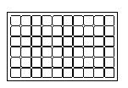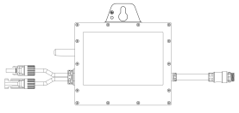
electrified wire netting
Grid-connected metering device
Micro inverter
Photovoltaic modules
- Connection diagram of a single micro-inverter
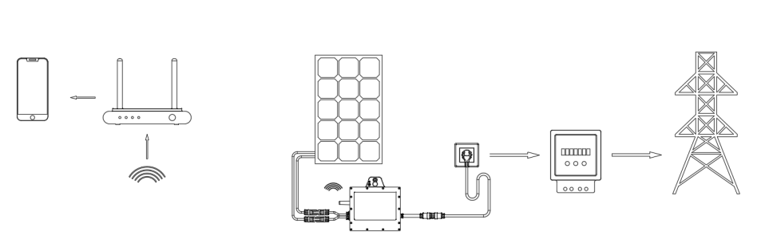

Overview of the micro-inverters
- A micro-inverter is a module-level solar inverter that can track the maximum power point of each photovoltaic module.
- When one photovoltaic module fails or is blocked, the other modules are not affected.
- The micro-inverter can monitor the current, voltage and power of each module to realize the module-level data monitoring.
- The micro inverter has the characteristics of low pressure DC, which eliminates the risk of personnel exposure to dangerous HVDC.
- The micro inverter is simple to install and can be changed according to the number of photovoltaic modules.
- The micro-inverter shell is designed for outdoor installation and complies with the IP67 protection grade standard.

compatibility
Please see the "Data Sheet" in this manual to verify the electrical compatibility of PV modules, please always order PV modules suitable for microinverters.

Visual dimensions (mm)
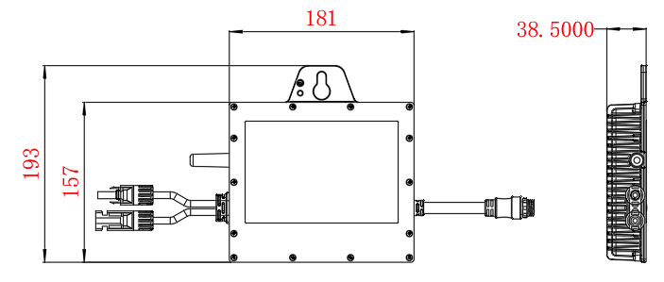

function Introduction
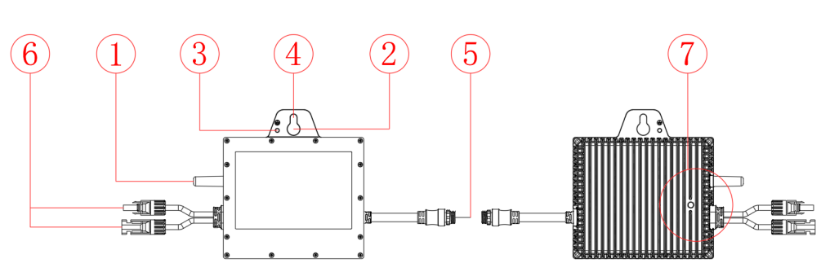

Item times | explain
1 | antenna
2 | handle
3 | Ground hole
4 | mounting hole
5 | The AC output connector
6 | The DC input connector
7 | LED pilot lamp

System monitoring
The micro inverter is connected to the Internet through the broadband router, and when connected to the system platform according to the operating instructions, the platform will display the current and historical performance trends and inform the status of the photovoltaic system in real time.

install

Installation requirements
The connection between the equipment and the power grid must be cut off, and the photovoltaic modules must be shaded or isolated.
Ensure that the environmental conditions meet the requirements of the micro-inverter (protection grade, temperature, humidity, altitude, etc.).
Avoid direct sunlight to prevent power reduction caused by temperature inside the micro inverter.
Please place the inverter away from the gas or flammable materials.
Avoid electromagnetic interference, because it will affect the normal operation of the electronic devices.
The stripe on the back of the micro inverter is the heat sink. When installed, ensure that the heat sink is above 20CM from other objects and keep a ventilated state
pour:
  - If you want to check and use the solar system immediately, it should be assembled in clear weather.
  - We recommend that at least three people work together during the assembly or disassembly process.

Install the required parts and tools

Protective gloves * 1
Protective gloves * 1
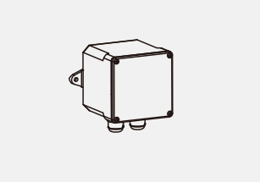pour: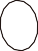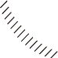
Terminal box * 1

M8 screws * 1

M8 nut * 1

Tie with * 10

Screw knife * 1

Hexagon wrench * 1

Wrench * 1

Voltmeter * 1
Voltage meter * 1
  - Except for the equipment and accessories in the delivery list, other tools should be prepared by themselves.

Installation steps
The installation of the microinverter involves the following key steps, each step described in detail below.
Step 1-Planning and installation of micro-inverters
Step 2-Layout the AC cables
Step 3-Micro-inverter connection
Step 4-Connect the junction box
Step 5-Create the installation diagram
Step 6-Connect the photovoltaic modules
Step 7-The System is energized
Step 8-Establish the monitoring system
Step 1-Planning and installation of micro-inverters
- Mark the position of each microinverter on the guide rail according to the photovoltaic module layout.
- Attach the screws to the guide rail.
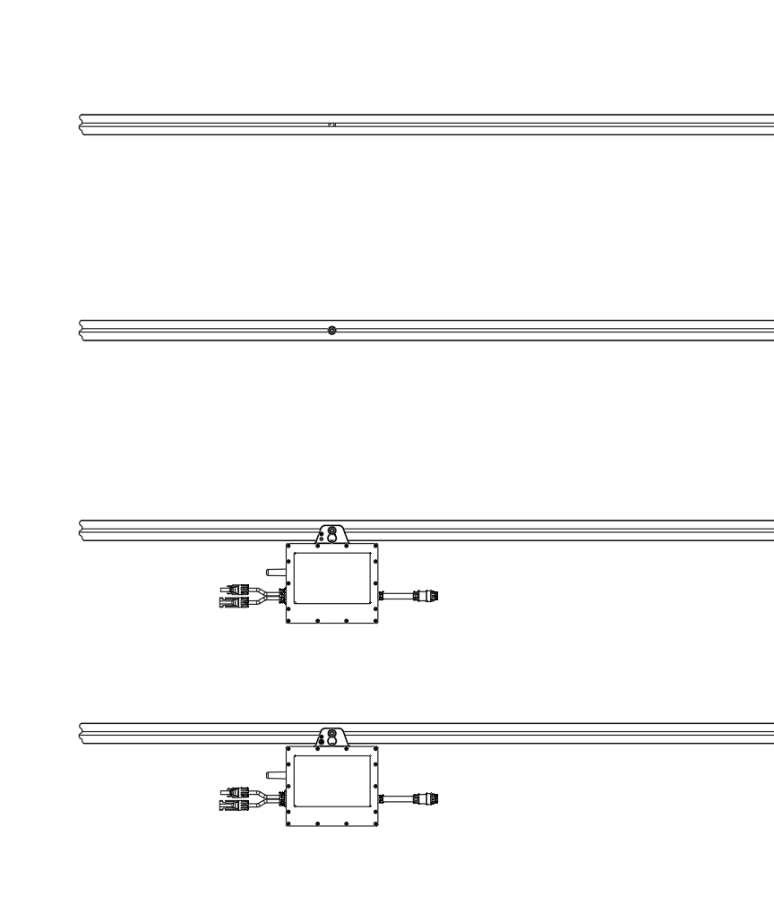
- Hang the micro inverter on the screw and tighten the screw.
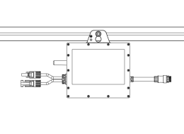
Figure A
Figure B
Figure C
* Microinverters must be installed under the photovoltaic module to avoid direct sunlight, rain, snow, ultraviolet light, etc.
The AC cable contains the ground wire and can be directly grounded. For the areas with special requirements, we provide the grounding bracket. Pass the continuous grounding cable through the micro-inverter grounding bracket and connect to the electrode conforming to the local regulations to complete the grounding requirements.
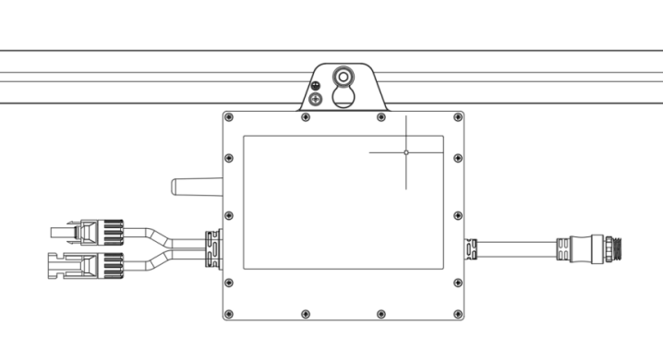
Install the ground support wire in the ground hole at the top of the micro inverter with a screwdriver and tighten the screw to 2N.m。
Step 2-Layout the AC cable
- Determine the number of microinverters installed on each AC branch and prepare the corresponding number of AC cables.
- Select the appropriate length of AC cable according to the distance between the microinverters. Advance extra length for connection, stalling and bending.
- The trunk AC cable is laid on the guide rail and simply fixed to connect the miniature inverter to the trunk.
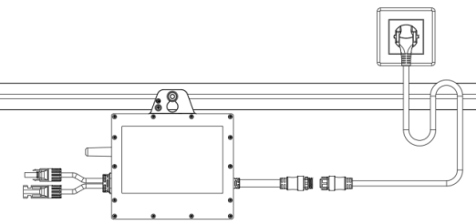
Step 3-Parallel miniature inverter
- Point the interface of the trunk AC cable to the right AC output port of the micro inverter until the "click" and tighten it to 9N.m。
- Repeat the above operation and connect the micro-inverter to the same branch line.
- Fixed AC cable using rolled rolling.
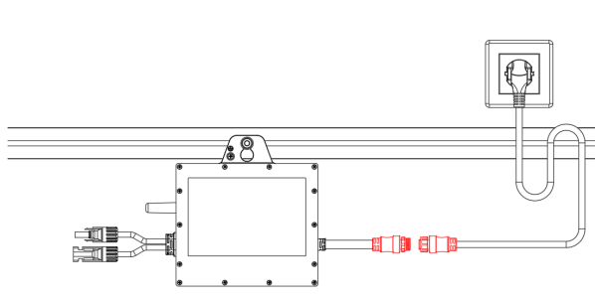
* The number of microinverters in the same branch line shall not exceed the specified maximum number of connections.
Step 4-Connect the junction box
- The AC cable is connected to the micro-inverter AC output port.
- Connect the AC cable to the socket or junction box.
  - Connect to the socket.
  - Connect to the junction box.
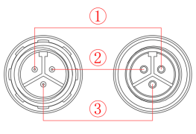
- ---L (Fireline)
- ---N(null line)
- ---PE (Ground wire)
* Interfaces and wires used by the microinverters.
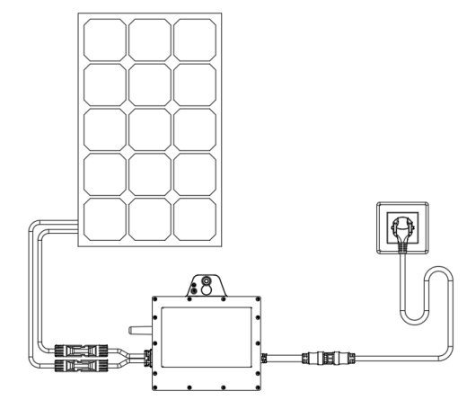
jack
Step 5-Create the installation diagram
- Peel off the removable label and attach the label to the position corresponding to the micro-inverter.
- According to the position of the micro-inverter in the whole system, put the corresponding label in the installation diagram.
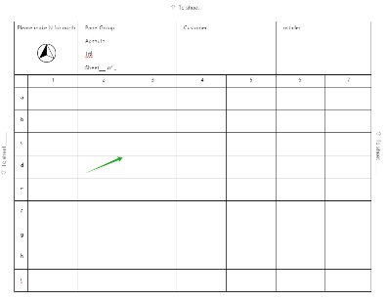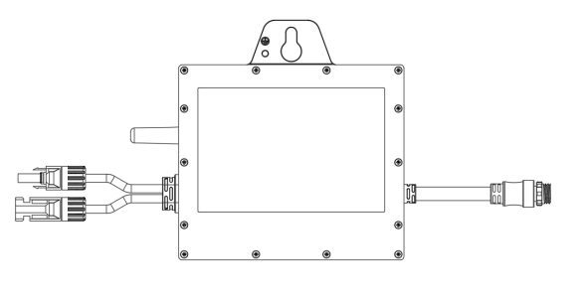
Step 6-Connect the photovoltaic modules
- Install the photovoltaic modules.
- Connect the DC cable of the photovoltaic module to the DC input port of the micro inverter.
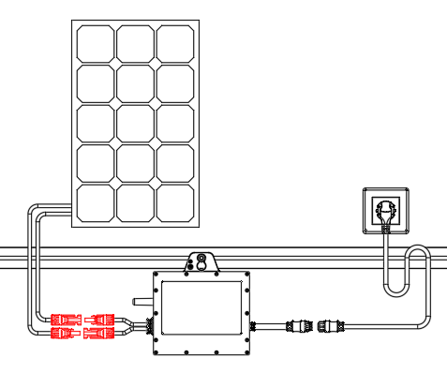
* A DC cable for a photovoltaic module must be connected to the DC input port on the same side of the micro inverter.
* The power of the photovoltaic module shall meet the input requirements of the micro-inverter, please refer to the data sheet.
Step 7-The System is energized
- Open the AC circuit breaker for the branch circuit.
- Turn on the main AC breaker on the house and the system will start generating electricity in about two minutes.

APP

download APP
With the application, you can remotely monitor and adjust the microinverters.
Search for "Smart Life" in the Apple App Store and other major app stores, or scan the QR code below to download the "Smart Life" APP.


Registered account
- Click Sign Up to read carefully and agree to User Agreement and Privacy Policy and go to page Register.
- Register an account with an email address or mobile phone number. State / Region is automatically specified and can also be changed manually. However, after account, this field value cannot be changed, click Get Ver i fication Code.
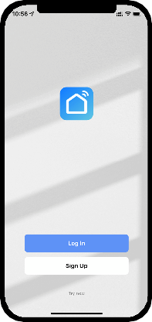
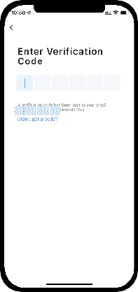
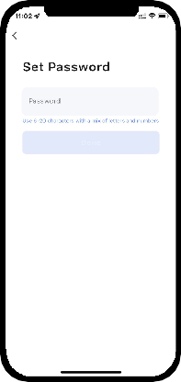
- 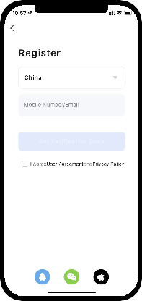Enter the received verification code, enter to the password Settings page, set the password as required, and click Done.
Germ any

Connect to the micro-inverter
- The distribution network mode is allowed within 3 minutes of starting up, and the AC is inserted and pulled three times within 20s to start the distribution network.
- Open the intelligent life APP, automatically pop up the micro inverter Add button, click Add to start to connect the micro inverter. If there is no Add button automatically displayed, you need to manually click the Add Devise button to search for nearby devices and enter the distribution network mode.
- Enter the Wi-Fi account and password, click the Next button after completion, wait for a few minutes, and the micro inverter completes the distribution network.
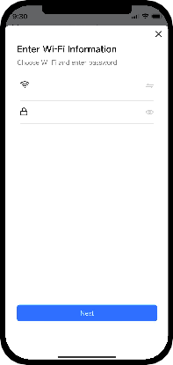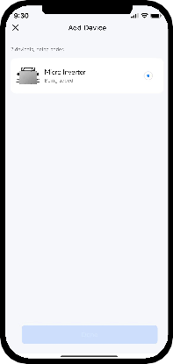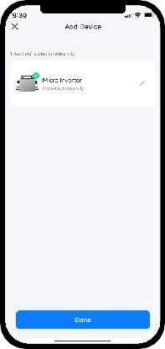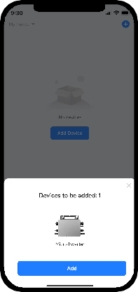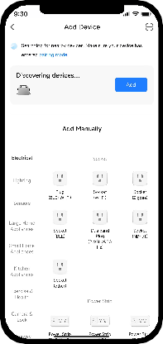

APP interface
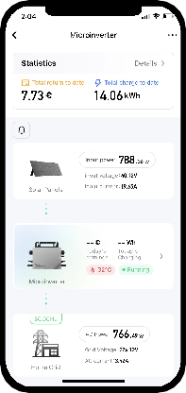
Grid data
Working data of the micro-inverter
Solar panel working data
Abnormal alarm
Accumulated power generation and power savings
Generated and historical data
- Click the Details to view the generation and historical generation data
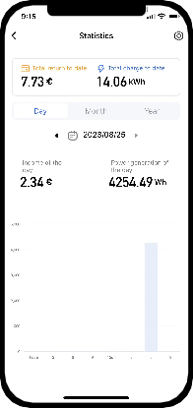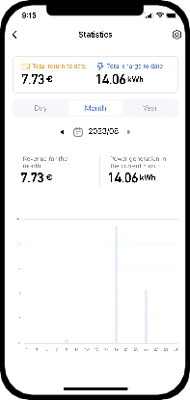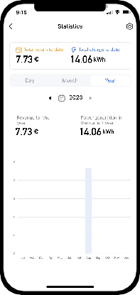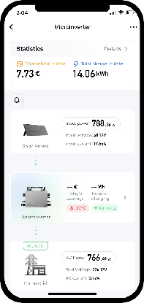
- Click the Settings button in the upper right corner to enter the Rate Settings screen to set the currency and power unit price.
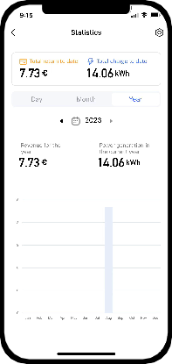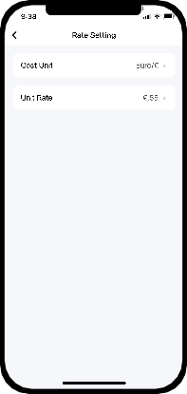

debugging

LED status indication

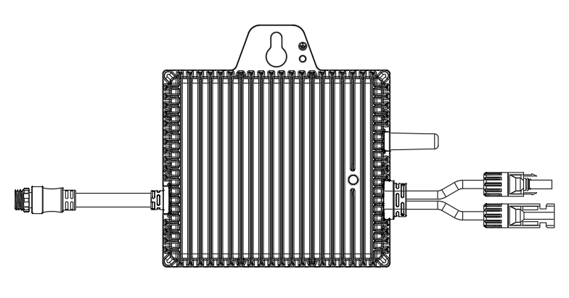
LED lamp status | State
Green light 4 seconds 1 flashing | normal operation
Red light 1 second 1 flashing | Overvoltage protection of municipal electricity
Red light 1 second 1 flashing | City power under pressure protection
Red light 1 second 1 flashing | Protection of mains
Red light 1 second 1 flashing | Overfrequency protection of municipal electricity

Replace the micro-inverter
Follow the following steps to replace the micro inverter
- Turn off the branch circuit breaker and disconnect the AC power supply.
- Disconnect the AC connector of the micro-inverter.
- Cover the PV module with an opaque lid to ensure that there is no current in the wire between the PV module and the micro-inverter.
- Disconnect the PV module connector on the micro-inverter.
- Remove the micro-inverter from the photovoltaic bracket.
- The micro inverter that will be replaced is installed to the photovoltaic bracket.
- Remove the shading cover from the PV module.
- Connect the photovoltaic module connector on the micro inverter.
- Connect the AC cable on the micro inverter to verify that the micro inverter is working correctly.
* The inverter must be replaced by a trained professional.
* The DC working voltage range of the pv module must match the allowable input voltage range of the micro-inverter.

Data sheet
Model | NBQ 400-EU | NBQ 500-EU | NBQ 600-EU
Input parameters (DC)
Solar panel input power is recommended | 200-430W× 1 | 200-530W× 1 | 200-625W× 1
Number of DC input connections | MC4 ×1
maximum input voltage | 60V
The DC voltage input range | 16-60V
starting voltage | 22V
Maximum power point tracking voltage range | 22-55V
MPPT, and the tracking accuracy | >99.5%
Maximum input DC flow | 14A*1 | 16A*1 | 18A*1
Output Parameters (AC)
maximumoutput | 400W | 500W | 600W
Rated output voltage | 230V
AC voltage range | 190-270V
maximum output current | 1.74A | 2.17A | 2.6A
Rated output frequency | 50Hz/60Hz
Output frequency range | 47.5-50.5Hz/58.9-61.9Hz
Harmonic distortion | <5%
Output power factor | >0.99
Maximum conversion efficiency | 96%
Protection level | Class I
Defencive function
Overvoltage / undervoltage protection | Yes
Overfrequency / underfrequency protection | Yes
Prevent the isolated island effect of protection | Yes
overcurrent protection | Yes
overload protection | Yes
Overtemperature protection | Yes
levels of protection | IP67
operating temperature range | -40℃ to +65℃
pilot lamp | Operating status light + Wi-Fi signal lamp
Communication mode | Wi-Fi / 2.4G
cooling-down method | Natural cold (fanless)
work environment | Indoor / outdoor
weight | 1.9kg
Dimension (L * W * H) mm | 181mm*193*38.5mm
meet a criterion | EN50549; EN62109;IEC62321

Appendix

Attachment 1. Installation map
Inst aller: | 7
Inst aller: | 6
Customer ： | 5
Customer ： | 4
P anel Gr oup:  A zimuth.T itl.  Sheet___of___ | 3
P anel Gr oup:  A zimuth.T itl.  Sheet___of___ | 2
Please make N for north | 1
Please make N for north |  | a | b | c | d | e | f | g | h | i

Attachment 2 wiring diagram
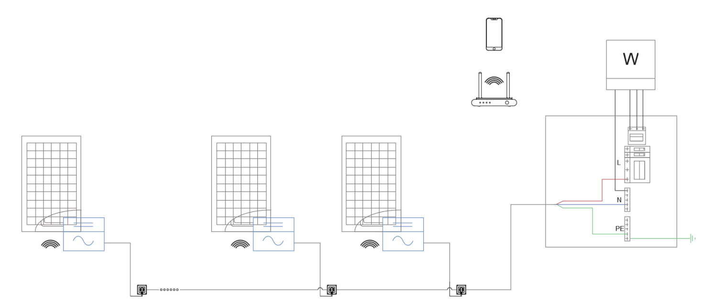

614-00065-00

